Introduction
Harvest Link is a platform based in Cape Town that connects mall scale farmers to institutional buyers like schools, community kitchens, and local feeding programs. This platform is designed to strengthen the South Africa’s food system by building on the principles of economic dignity and community resilience.
Traditional retail requirements and middlemen that favour major producers can now be bypassed by small producers; they can now receive fair market access and returns for their surplus harvest.
Vulnerable populations now have affordable access to fresh produce through the Harvest Link platform. The platform also provides key data regarding the seasonal harvest calendar/guide, helping clients plan their menus based on what is currently growing and what is not.

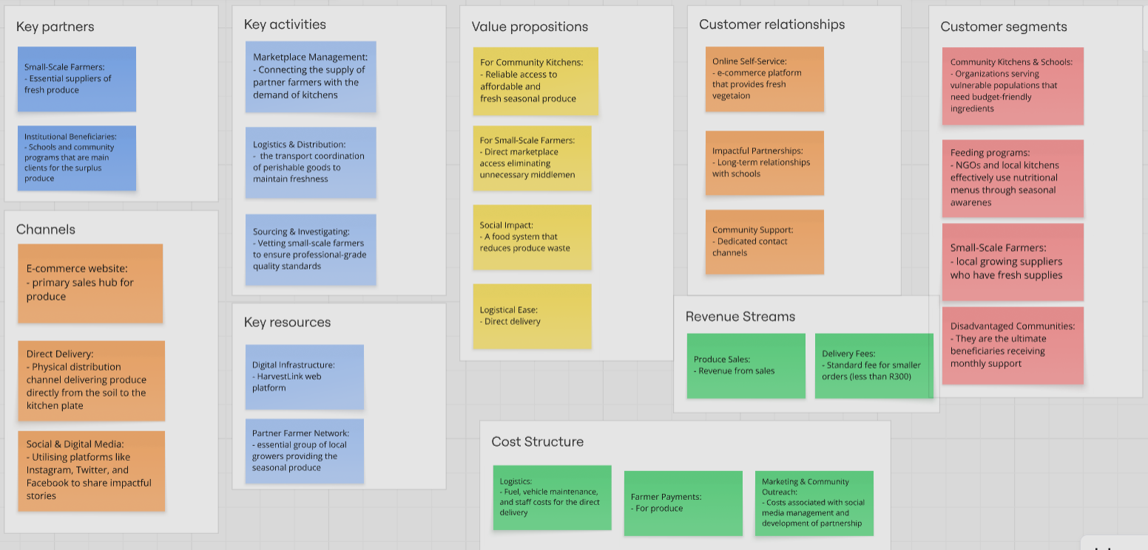
Business Canvas:

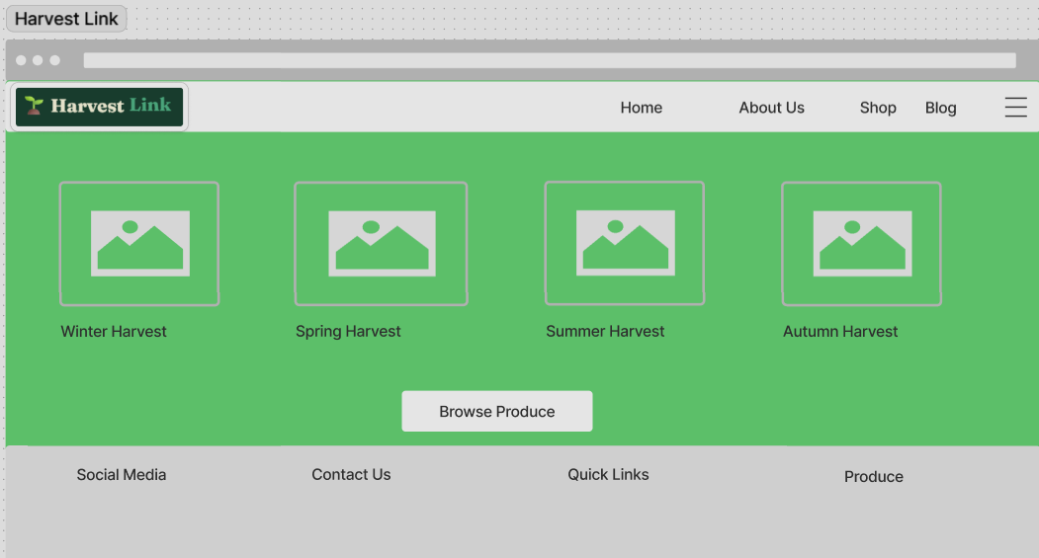
Wire frames:
- Home Page
This wireframe shows the design of the “Home” page which contains information about the platform and what it provides. It also contains a footer that displays the contact details, quick links (social media pages), and produce.
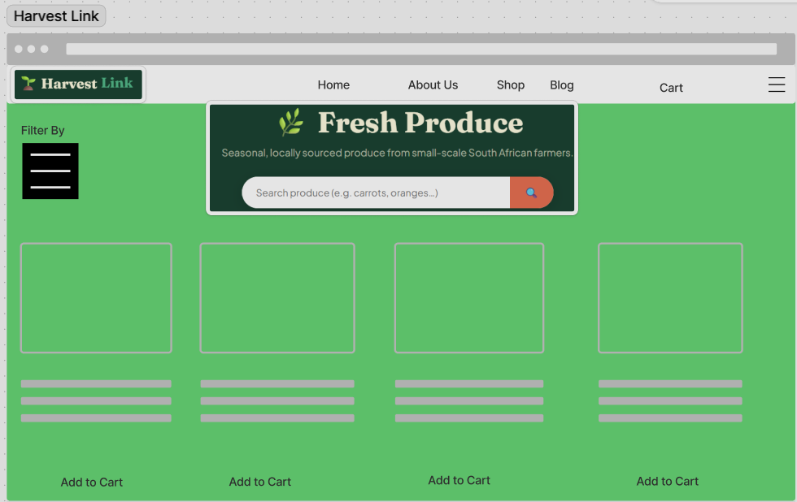
- Products Page:
This wireframe shows the main “Product” page. This is where all the products being sold are displayed and where clients can search for specific produce or filter by a specific category.
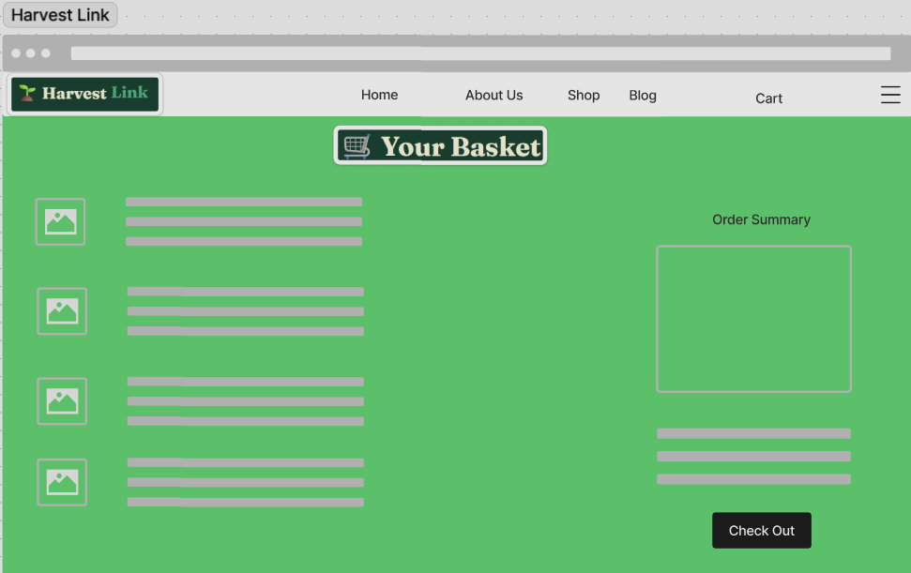
Check-out Page:
This wireframe is of the “Cart” page where all the products in the cart are shown as well as the order summary. The client has the option to finally check out and purchase the items in the cart.

User Personas:
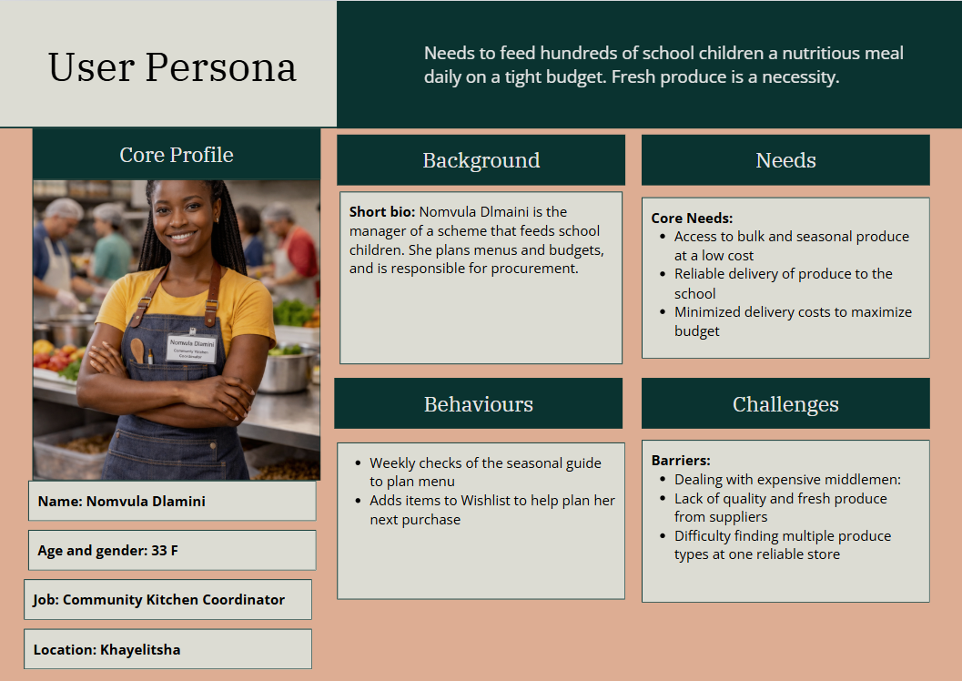
- Community Kitchen Coordinator – Nomvula Dlamini

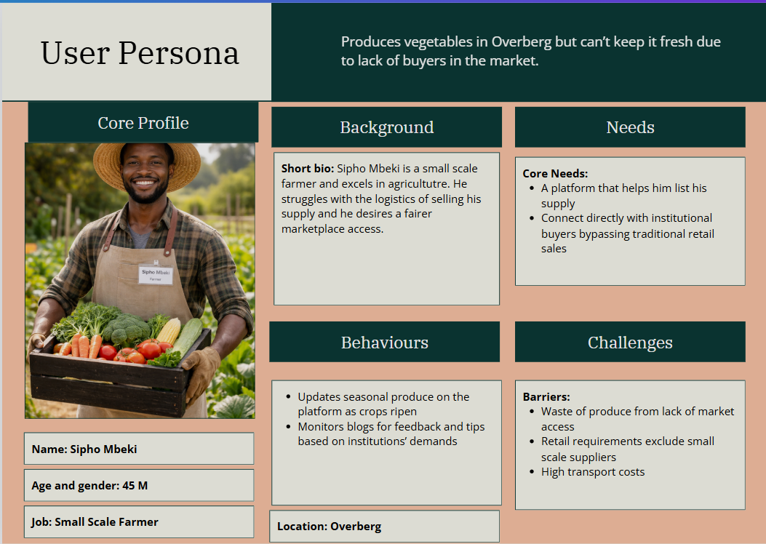
- Small scale farmer:

Hierarchical Task Analysis:
Producing fresh produce for the kitchen for users like Nomvula is the primary goal.
- Procurement of fresh produce for the kitchen:
  - Identifying Seasonal Availability:
    - From the “Home” page, navigate down to the “Seasonal Guide”
    - Review the guide for real-time seasonal produce information
  - Select Produce:
    - Navigate to “Shop” page
    - Use filter or search bar to find specific produce
    - Add items to wishlist or cart
  - Manage cart:
    - Navigate to “Cart” page
    - Enter Promo code
    - Checkout
  - Transaction completion:
    - Input delivery details
    - Choose payment method
    - Enter payment details
    - Confirm order

